Recycled denim
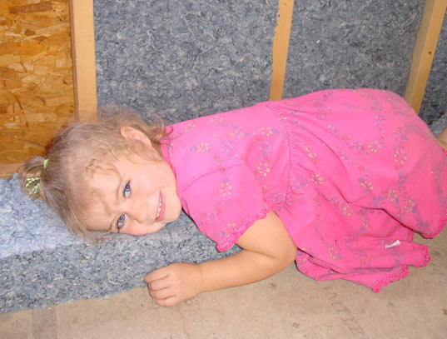
There are a lot of promising new materials being used for insulation these days. Some, like wool and cotton (above), have been used successfully for thousands of years and are finally being rediscovered by mainstream markets for their combination of high R values and simple, natural organic qualities. Other substances like Nanogel and Icyene are patently high-tech and non-organic, yet their special qualities permit new developments in insulation such as spray-in-place quick fixes, and translucent insulating walls.
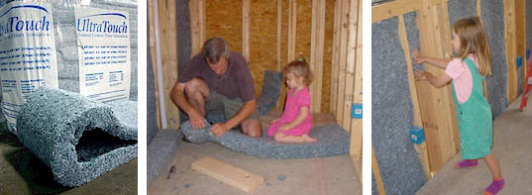
RECYCLED DENIM (COTTON) INSULATION
This is my favorite choice by far! This organic insulation is made from recycled blue jeans – how cool is that? Bonded Logic’s UltraTouch brand of denim insulation is 100% recycled, and since its good old fashioned cotton, you know its not going to off-gas any nasty chemicals into your house. Better yet, it installs quickly, comfortably and easily – requiring no special equipment and no protective clothing. As these photos attest, you can even get your kids to help install

